Bi-Weekly Progress Report
AI Chatbot Development
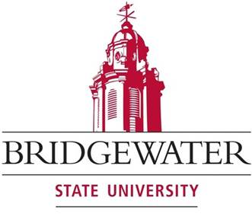
By
Muhammad Ovais Yusuf
Computer Science Graduate Internship S26 (COMP 598)
Masters of Science in Computer Science (MS CS)
Bridgewater, Massachusetts

Project Overview
The objective of this internship is the development and deployment of two AI chatbot systems for the Metro South Chamber of Commerce (MSCC). The first is an internal accreditation assistant designed to support staff in preparing and reviewing accreditation materials using a document-grounded approach. The second is a public-facing website chatbot aimed at assisting members and visitors with inquiries related to events, membership, and chamber services. These systems are intended to improve operational efficiency, reduce manual workload, and enhance user engagement through AI-driven automation.

Key Accomplishments (Weeks 9 & 10)
• Website Chatbot Functional Completion: Completed a working version of the public-facing chatbot capable of answering user queries related to events, membership, business resources, and general MSCC information.
• Content Integration from Official Website: Extracted and structured key information from the MSCC website and integrated it into the chatbot’s knowledge base, improving response relevance and accuracy.
• Response Quality Improvements: Refined prompt structure and response logic to ensure consistent, clear, and user-friendly answers aligned with real-world website interactions.
• Fallback and Scope Control Implementation: Implemented strict response boundaries to ensure the chatbot only answers questions based on available MSCC content and appropriately handles out-of-scope queries.
• User Experience Enhancements: Improved the chatbot greeting, tone, and interaction flow to make it more intuitive and helpful for general users.
• Initial Testing and Validation: Conducted multiple test scenarios through the chatbot interface to validate response accuracy, consistency, and behavior across different types of user queries.
• Internal Bot Handover for Testing: Delivered the internal accreditation chatbot for initial testing by MSCC staff (Emma), marking the transition from development to evaluation phase.
Technical Progress
• Successfully implemented a complete end-to-end pipeline for the website chatbot:
user query → backend processing → AI response → UI display
• Improved knowledge structuring by separating and organizing website-based content for more accurate retrieval and response generation
• Strengthened prompt engineering to balance helpfulness with strict content grounding
• Ensured stable API communication and consistent response handling across multiple test cases
• Maintained a modular backend architecture to support future expansion (e.g., additional data sources, improved retrieval mechanisms)
Upcoming Milestones
• Advanced Testing & Feedback Integration: Incorporate feedback from MSCC staff testing to refine both chatbot accuracy and usability
• Website Deployment Coordination: Collaborate with MSCC web development partners to explore integration of the chatbot into the live website
• Content Expansion: Enhance the chatbot’s knowledge base with additional structured website data and resources
• Performance Optimization: Improve response latency, consistency, and overall user experience
• Feature Enhancements: Explore improvements such as better query understanding, structured responses, and enhanced conversational flow
• Final System Refinement: Prepare both internal and public chatbot systems for stable, real-world deployment

